REACT JS LAB RESULTS

DISPLAYING THE LIST OF ITEMS

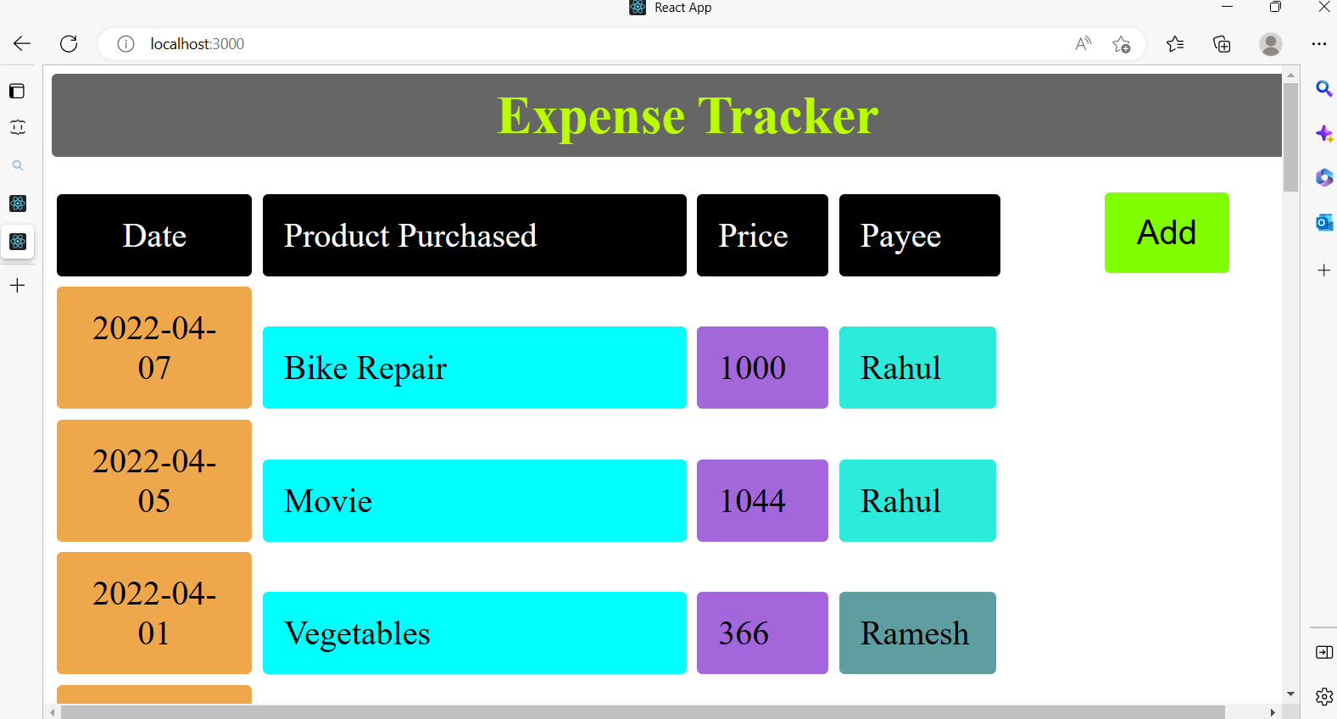

ABLE TO ADD ITEM (eg XYZ)

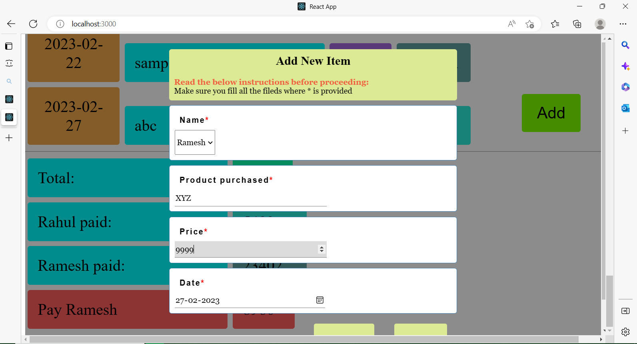

THE ADDED ITEM XYZ IS DISPLAYING IN THE LIST

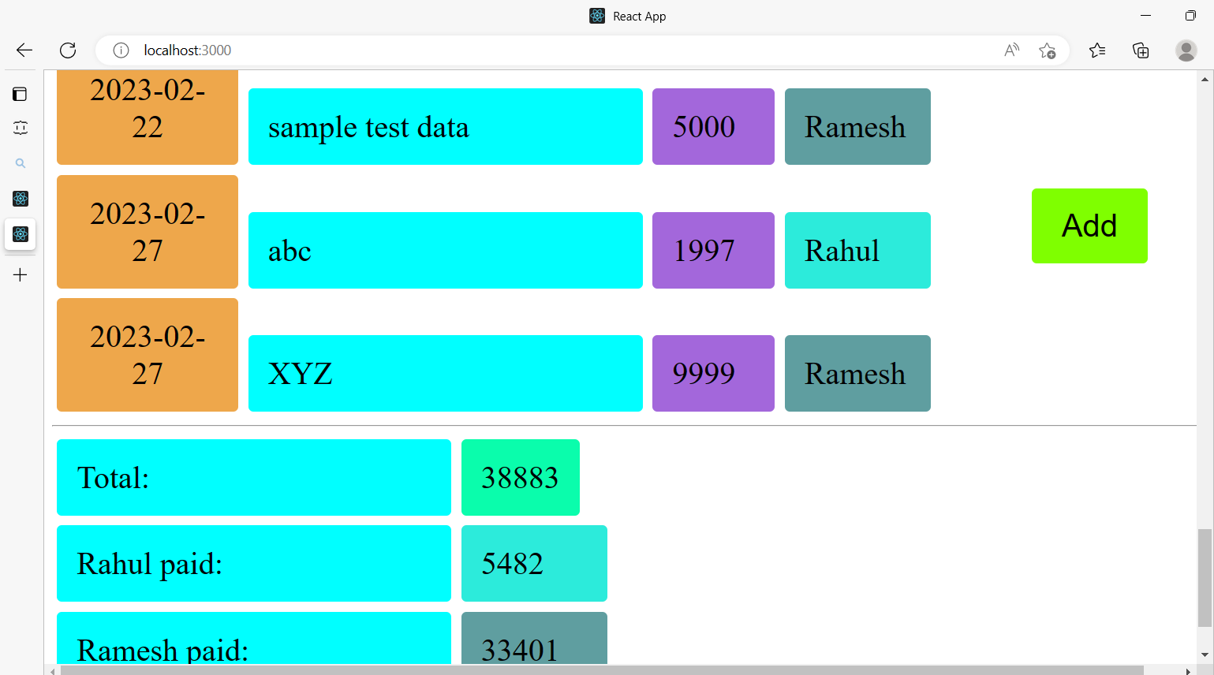

CORRESPONDING DATA REFLECTING IN BACKEND JSON SERVER ALSO

